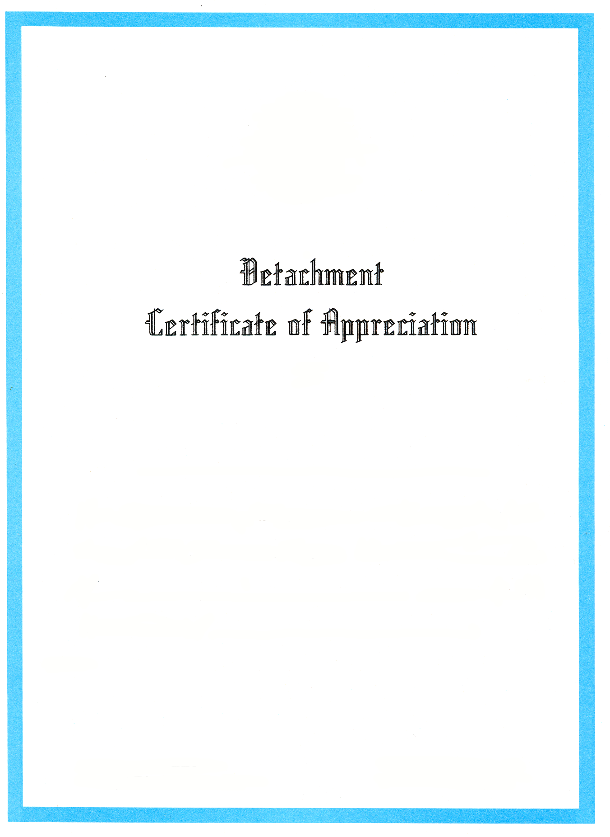

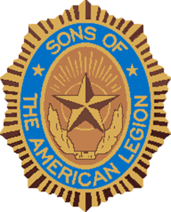

To

West Tawakoni Squadron 517
100% Membership Achiever

For the promotion of the programs and principles of the
Sons of The American Legion.
Given this 8th day of June, 2024
by the Detachment of Texas.

Attest:

Roy Fowler | Lewis Elam
Detachment Commander  Sons of The American Legion | 1st Division Commander  Sons of The American Legion

