2026
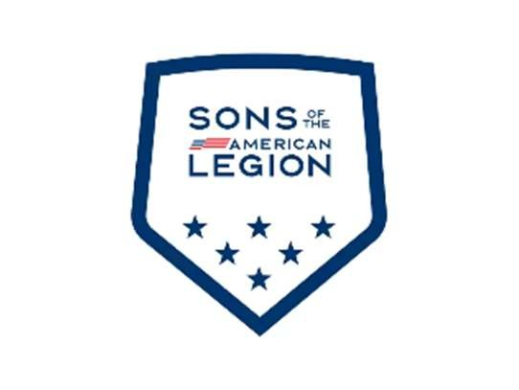

SONS OF THE AMERICAN LEGION NATIONAL CHILDREN & YOUTH 250 ACADEMY REGISTRATION FORM

Participant full name:___________________________________________________________________________
DOB:____________ Age: ________ Participant gender: (M/F) Grade level: ____________________
Have you attended the Youth Academy before: (Y/N)
If you answered yes above, what year(s): ___________________________________________________________
Is the participant a member of The American Legion Auxiliary: _____ (Y/N) Department: ____________________
Is the participant a member of the Sons of The American Legion: _____ (Y/N) Detachment: __________________ Length of membership in years: ________________
Has the participant held any positions in The American Legion Family (please list position): __________________
____________________________________________________________________________________________
____________________________________________________________________________________________Has the participant received any formal training in American Legion Family programs, traditions, etc.
(please describe the training): ____________________________________________________________________________________________
____________________________________________________________________________________________
Is there any training you would like to see covered: __________________________________________________
____________________________________________________________________________________________
____________________________________________________________________________________________
Allergies: ____________________________________________________________________________________________
____________________________________________________________________________________________

<OVER>

2026

Name of parent/guardian:_______________________________________________________________________
Contact #: ___________________________________________________________________________________
Email Address: _______________________________________________________________________________

EMERGENCY CONTACT INFORMATION
(Please complete if different than the parent/guardian)

Contact name #1: ________________________________________ Relationship:____________________________________________ Contact #: ____________________________
Email address: ________________________________________________________________________________
Contact name #2: ________________________________________
Relationship: ____________________________________________ Contact #: ____________________________
Email address: ________________________________________________________________________________

I GIVE THE FOLLOWING PEOPLE PERMISSION TO COLLECT MY CHILD
(Please complete if someone other than parent/guardian will be picking up the participant)

Name: ______________________________________________ Relationship: ____________________________ Name: ______________________________________________ Relationship: ____________________________

SIGNATURE OF PARENT/GUARDIAN:
x______________________________________________________________

For planning purposes, the National Children & Youth Committee asks that you please submit your completed registration by 07/31/2026. Walk-ins the day of the event will be accepted. Please return the completed registration via email to: jefftrout65@gmail.com or mail the completed registration to:
Jeff Trout
1016 US Highway 45
Enfield, IL 62835

